User Manual

Table of Contents

1. **Home Screen……………………………………….1**
2. **Credits Screen……………………………………...2**
3. **Settings Screen……………………………………..3**
4. **Tutorial……………………………………………..4**
   1. Page 1………………………………………......4
   2. Page 2…………………………………………..5
   3. Page 3…………………………………………..6
   4. Page 4…………………………………………..7
5. **Gameboard…………………..…………………….8**
   1. No focus………………………………………..8
   2. Tile focus……………………………………....9
6. **Victory Screen……………………………………10**
7. **Defeat Screen……………………………………..11**

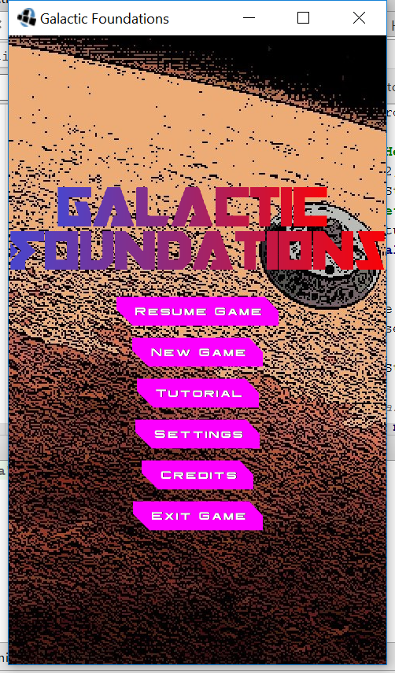

Figure 1: Home Screen

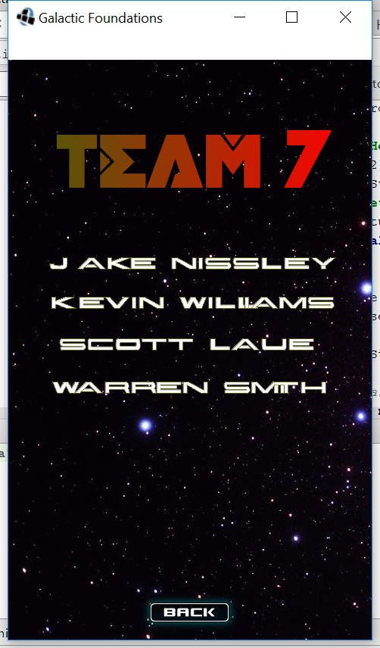

Figure 2: Credits Screen

Figure 3: Settings Screen

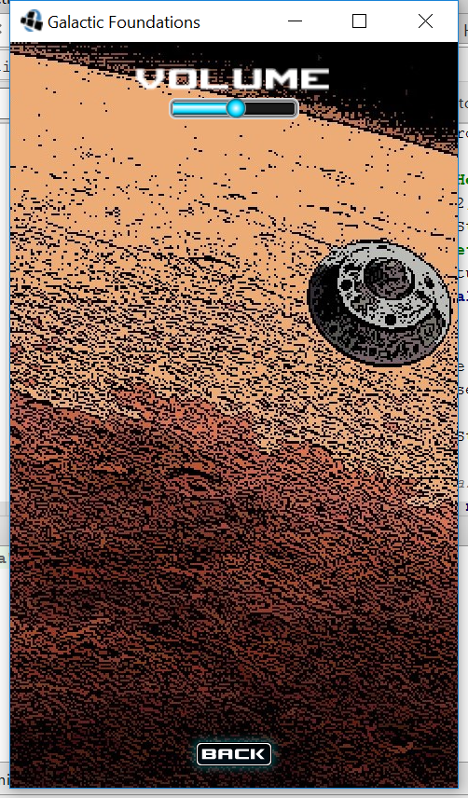

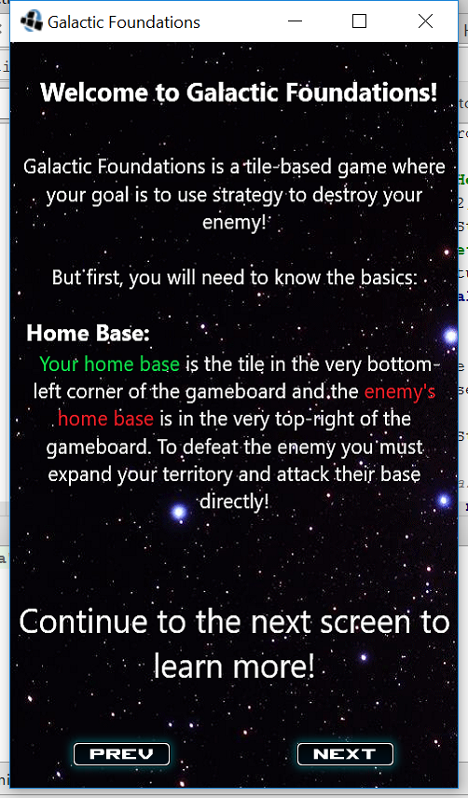

Figure 4: Tutorial Page 1

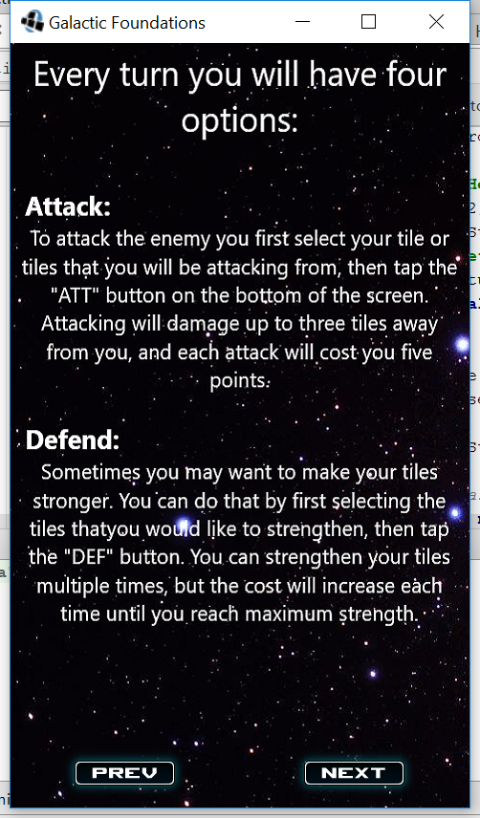

Figure 5: Tutorial Page 2

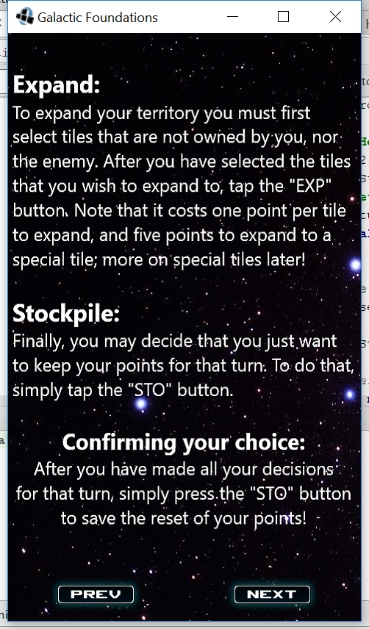

Figure 6: Tutorial Page 3

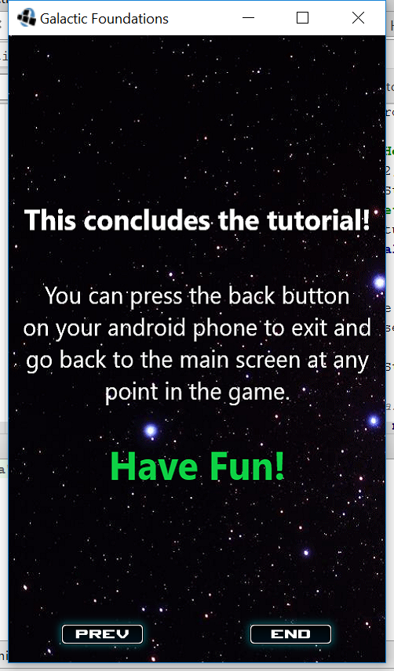

Figure 7: Tutorial Page 4

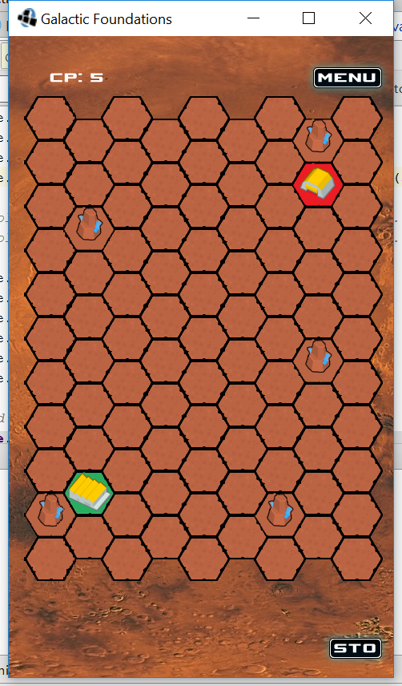

Figure 8: Gameboard No Focus

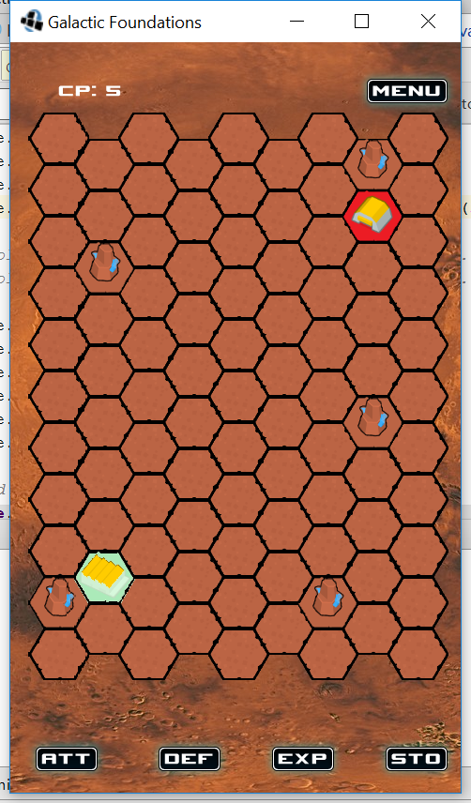

Figure 9: Gameboard Tile Focus



Figure 10: Victory Screen

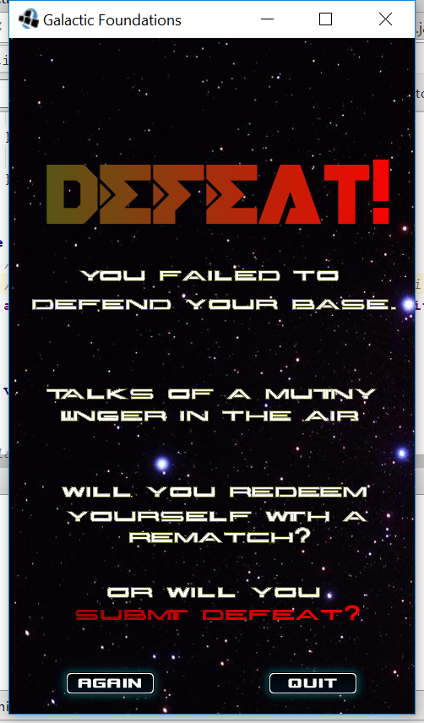

Figure 11: Defeat Screen